[](http://www.ecs.baylor.edu/engineering/bears/)

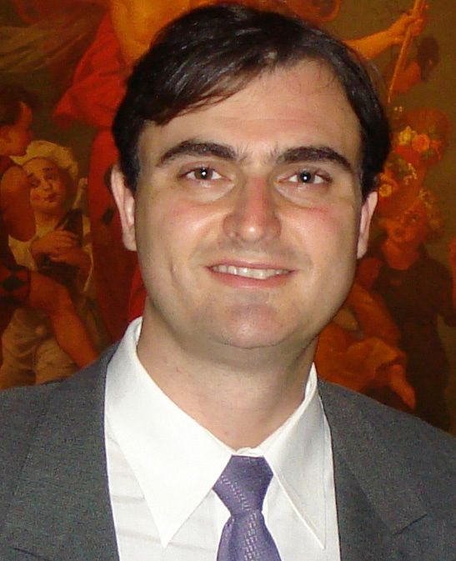 “CMOS-Based Microsystems for Biomedical Applications”

**Diego Barrettino, Ph.D.**

Associate Professor,

University of Applied Sciences of Southern Switzerland

Tuesday, Feb 25, 2014, 2 PM, 312 Rogers Bldg

**Abstract:**

Research activities on biomedical microsystems are currently directed towards system-on-chip (SoC) and system-in-package (SiP) solutions, which are becoming more complex and demanding in terms of functionality, size and power consumption. At the same time, the time-to-market and the price of biomedical microsystems must be reduced.

On the other hand, even though the performance of micromachined sensors and actuators for automotive and consumer applications is increasing every year, these micromachined devices do not necessarily meet the demanding system specifications for biomedical applications. Therefore, sophisticated readout and control electronics have to be designed and integrated with the micromachined sensors to respond to such challenges.

This talk will first introduce some relevant features of CMOS technology and then the design and development of biomedical microsystems will be illustrated in detail by presenting some examples of CMOS-based biomedical microsystems comprising micro-electro-mechanical devices (membranes or cantilevers) and the associated readout and control electronics.

**Biography:**

**Diego Barrettino** (S’93–M’98–SM’06) received the Diploma degree in electronic engineering from the University of Buenos Aires, Argentina, in 1997, and the Ph.D. degree in electrical engineering from the Swiss Federal Institute of Technology Zurich (ETHZ), Switzerland, in 2004.

He worked at Allegro MicroSystems Inc., from 1997 to 2000, where he was an Analog IC Designer of Hall-effect magnetic sensors. From 2000 to 2004, he was a Doctoral student and Research Assistant at ETHZ, where he designed chemical and mechanical sensors. In 2004, he moved to the USA where he designed biomedical devices first as a Postdoctoral Research Associate in the University of Washington, Seattle, and then as an Assistant Professor in the University of Hawaii, Honolulu. In 2006, he returned to Europe where he joined the Swiss Federal Institute of Technology Lausanne (EPFL), Switzerland, as a Senior Research Scientist for the design and development of biosensors using organic nanotransistors. From 2007 to 2009, he was a Lecturer in the University of Glasgow, U.K., and in the University College Cork, Republic of Ireland, where he designed ultra-low power biomedical devices. In 2009, he joined the University of Applied Sciences of Southern Switzerland (SUPSI), Manno, Switzerland, where he is an Associate Professor and the Head of the Laboratory of Microelectronics and Embedded Systems. His research interests are in the fields of physical, chemical, and biomedical microsensors; analog and mixed-signal IC design; MEMS; and embedded systems.